Android Programming Final Project Writeup

## Team members

Mengen Gao (mg63478)

## Title of your app and description

Cloudhired Mobile App – a mobile app where certified cloud professionals can show their certifications and connect with each other.

## Include a screenshot of your app, hopefully one that illustrates key functionality.

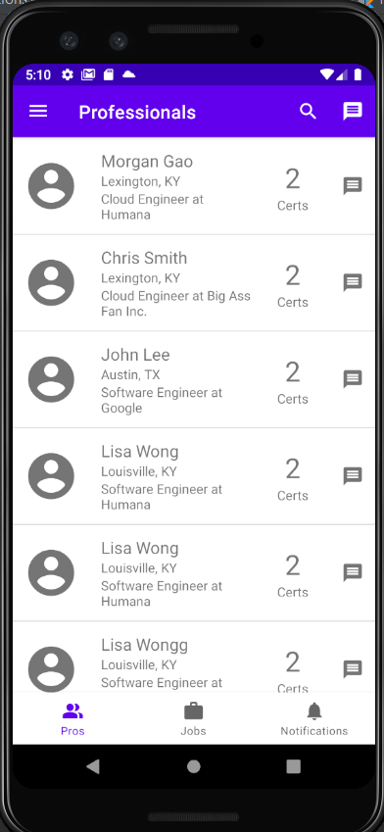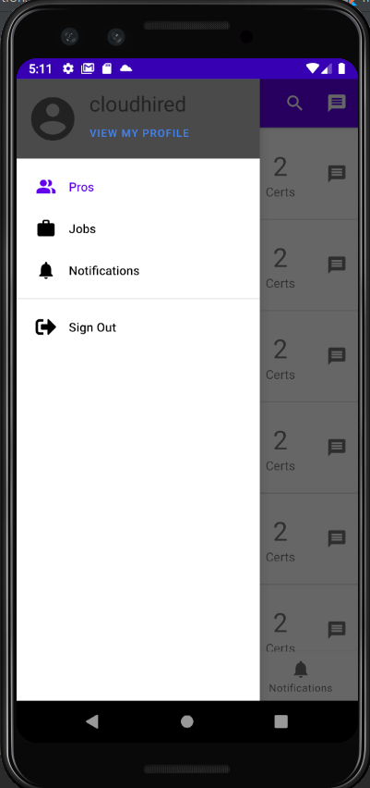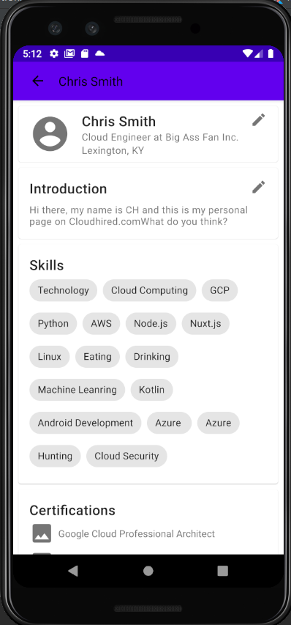

0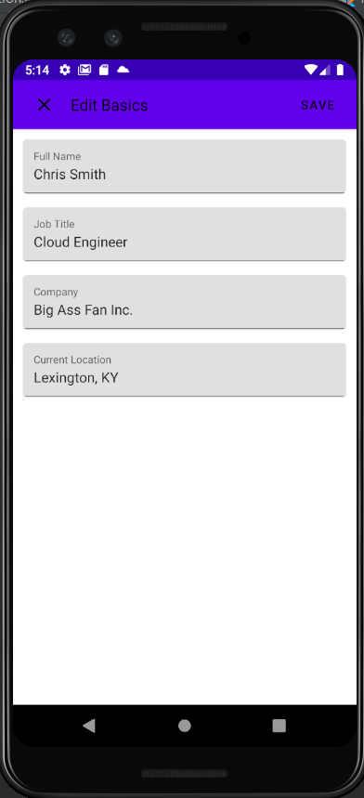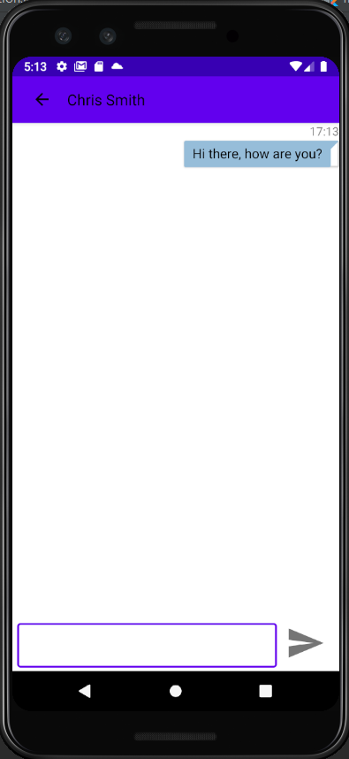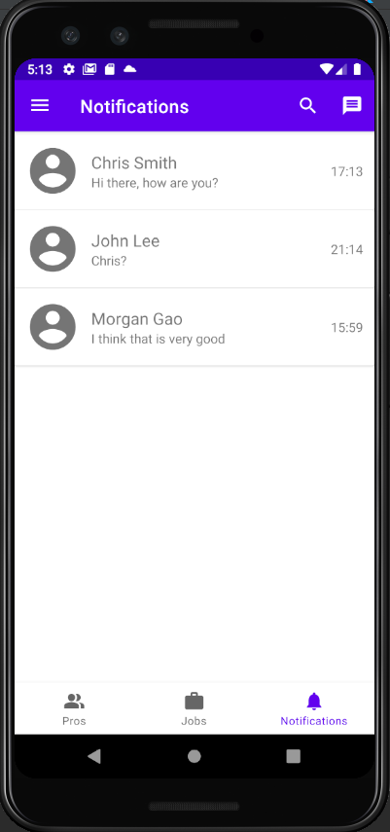

## APIs and Android features used

I am developing a web application called cloudhired.com where people can list their certifications and profile so they can get more exposure in job searching. The website is still under construction but I am able to open some APIs for my Android application to use. Those include:

* + [GET] <https://cloudhired.com/api/users> - list all users
  + [GET] [https://cloudhired.com/api/username/<username>](https://cloudhired.com/api/username/%3cusername%3e) - get profile of certain user by username
  + [GET] [https://cloudhired.com/api/email/<email>](https://cloudhired.com/api/email/%3cemail%3e) – get profile of certain user by email address
  + [POST] [https://cloudhired.com/api/email/<email](https://cloudhired.com/api/email/%3cemail)> - update user profile by email address

Other Android features I utilized include:

* + Navigation component
  + Bottom navigation bar
  + Side navigation bar with navigation drawer
  + Action bar

## Third party libraries

Retrofit – to help make RESTful calls. The challenging part of this is to find out how to make POST request as this is not used in our FC and HW.

## Third party services

Cloudhired.com APIs – the APIs I can get information about all users and pull each user’s profile. The challenging part is the web app is using Auth0 as authentication tool, but in my Android app, I need to use Firesbase to authenticate users. This creates a user information sync problem.

## Discuss anything noteworthy about your UI/UX/display code.

* + I am using Android navigation components for my app. I drew the navigation graphs and define actions for each graph. That way I can navigate between different fragments without problem. This is one pain point I had doing HW4 the Reddit app. It was messy navigating between different fragments in the app. With navigation component implemented, navigating becomes much easier.
  + The frontend of navigation component is carried by navigation menu. I used two types of navigation bars: bottom and side. For side navigation bar, I put it in the drawer.
  + Chat interface. I was trying to make it look as nice as possible. I spent whole afternoon making the chat message bubble.

## Discuss anything noteworthy about your back end or processing logic.

* + User information synchronization. Because the web app is using Auth0 and my app is using Firebase auth to authenticate users. When user register from web app, their user information can be pulled by Android app but not vice versa. So I had to figure out a way to synchronize users who registered via Android app to web app’s database. To do that, when user first registers, Android app won’t send their information to web app database until they try to edit their profile. When they click “view my profile” in the drawer, the Android app will do a query to web app db and register if it does not exist.
  + Chat messages organizing. The challenge is to have a data structure where each user’s chat messages with others can only bee seen by the two participants. I designed the data structure in Firebase database which can be found in the next section.
  + How to pull out the chats one user has participated. This is more of a Firebase database problem. I did some query based on the user’s email and pull the last message between them.

## Discuss the most important or interesting thing you learned doing your project.

I think the most important thing I learned is the full cycle of developing an Android application. Through out the semester I learned different pieces of building blocks. And the final project provides the opportunity to know other key features like navigation.

## Discuss the most difficult challenge you overcame and/or your most interesting debugging story.

The most difficult challenge is to set up the navigation component. From drawing the navigation graph to finally added a listener to the drawer item, it is very new for me.

## If necessary, briefly tell us how to build and run your project.

Build as normal. There is one circumstance the app might fail is when the API call is timed out. What you can do is to check if the web app is working (cloudhired.com) Usually it will come back if you build it second time. (Sorry I host my API on GCP app engine and set a minimum compute instance to 0 and it takes some time to respond when first called.)

* If you use firebase, include a printout (or screenshot) of your database schema.

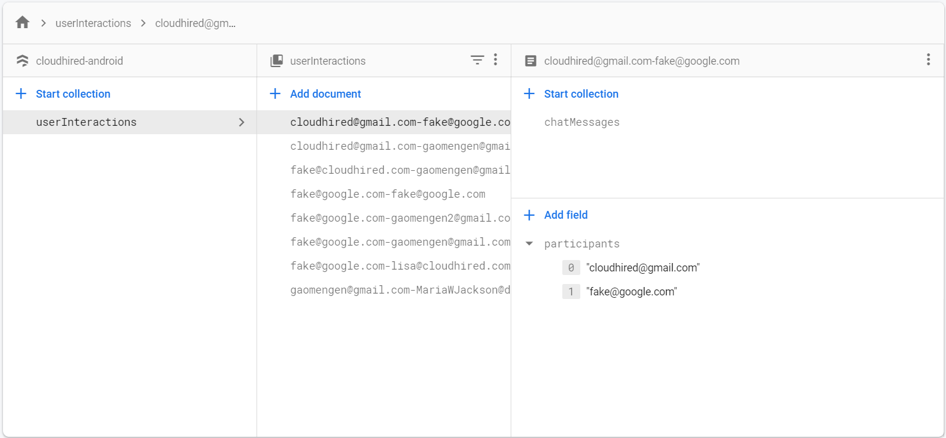

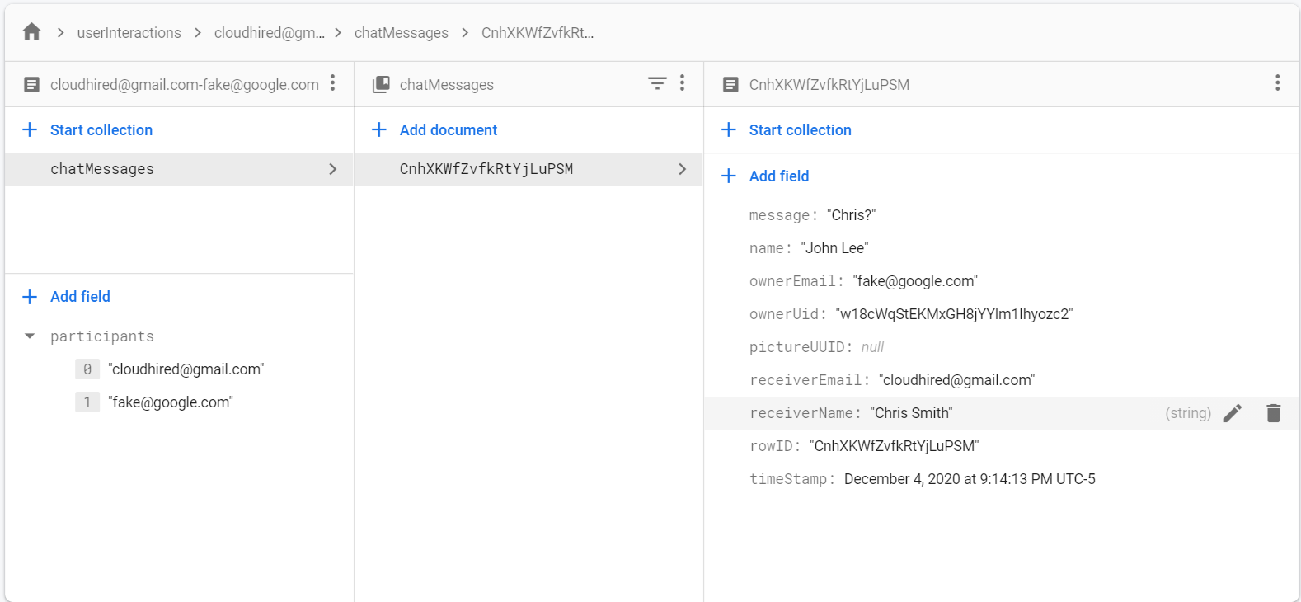

## Report the count of lines of code in your project

|  |  |  |  |
| --- | --- | --- | --- |
| Main modules | Includes main files | | Total number of lines wrote |
| View profile | view_my_profile.xml  view_profile.xml  ViewMyProfile.kt  EditMyProfile.kt  ViewProfile.kt  ProRowAdapter.kt  row_professional.xml  fragment_professionals.kt  fragment_professionals.xml  ProfessionalProfile.kt  edit_my_profile.xml  edit_basic.xml  edit_skills.xml  edit_intro.xml  ProfessionalSummary.kt  fragment_professionals.xml | | 1374 |
| Chat | row_chat.xml  view_chat.xml  ChatAdapter.kt  Chat.kt  fragment_notifications.kt  row_notification.xml  NotiRowAdapter.kt  fragment_notifications.xml  Notification.kt  ChatRow.kt | | 792 |
| Main | MainViewModel.kt  MainActivity.kt  activity_main.xml  CloudhiredApi.kt  AndroidManifest.xml  Repository.kt | | 428 |
| Auth | Auth.kt | | 59 |
| Layout | drawer_header.xml  drawer_main.xml  nav_graph.xml  drawer_menu.xml  bottom_navigation_menu.xml  top_app_bar.xml | | 184 |
| Total XML | | 1605 | |
| Total KT | | 1232 | |
| Total lines | | 2837 | |